Basic Visualization Tools

**Area Plots**

The area plot, which is actually an extension of the line plot. So what is an area plot? An area plot also known as an area chart or graph is a type of plot that depicts accumulated totals using numbers or percentages over time. It is based on the line plot and is commonly used when trying to compare two or more quantities.

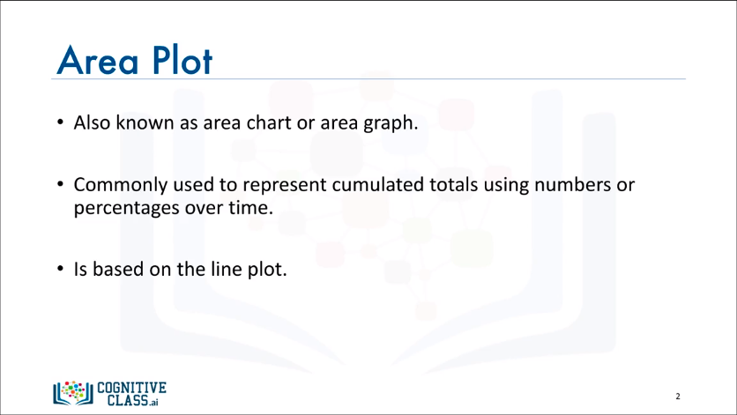

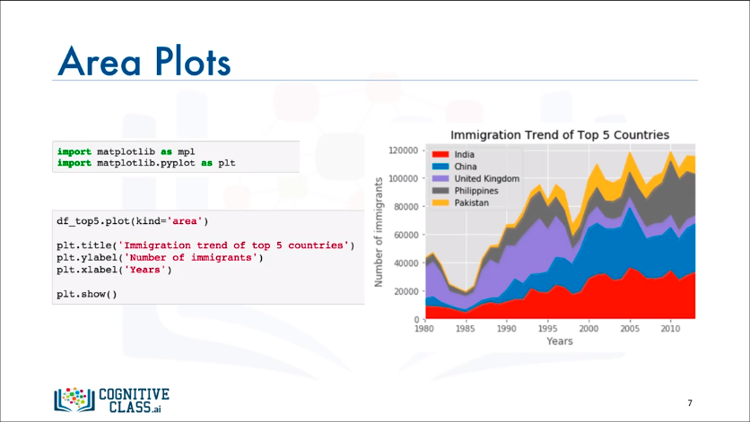

**Histograms**

A histogram is a way of representing the frequency distribution of a numeric dataset. The way it works is it partitions the spread of the numeric data into bins, assigns each datapoint in the dataset to a bin, and then counts the number of datapoints that have been assigned to each bin. So the vertical axis is actually the frequency or the number of datapoints in each bin.

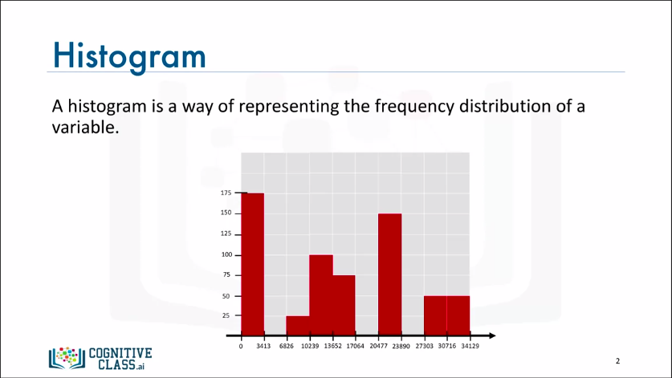

* For example, let's say the range of the numeric values in the dataset is 34,129. Now, the first step in creating the histogram is partitioning the horizontal axis in, say, ten bins of equal width, and then we construct the histogram by counting how many datapoints have a value that is between the limits of the first bin, the second bin, the third bin, and so on. Say the number of datapoints having a value between 0 and 3,413 is 175. Then we draw a bar of that height for this bin. We repeat the same thing for all the other bins, and if no datapoints fall into a bin then that bin would have a bar of height 0.

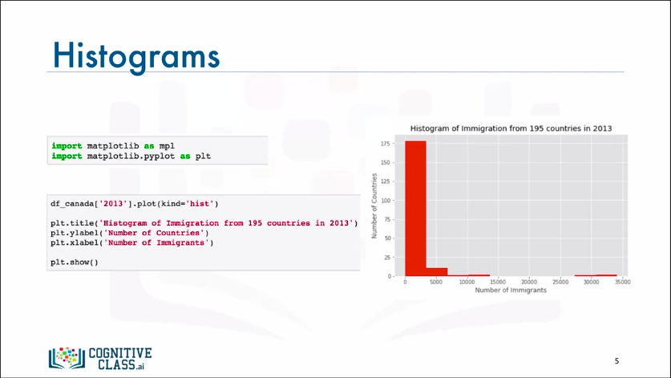

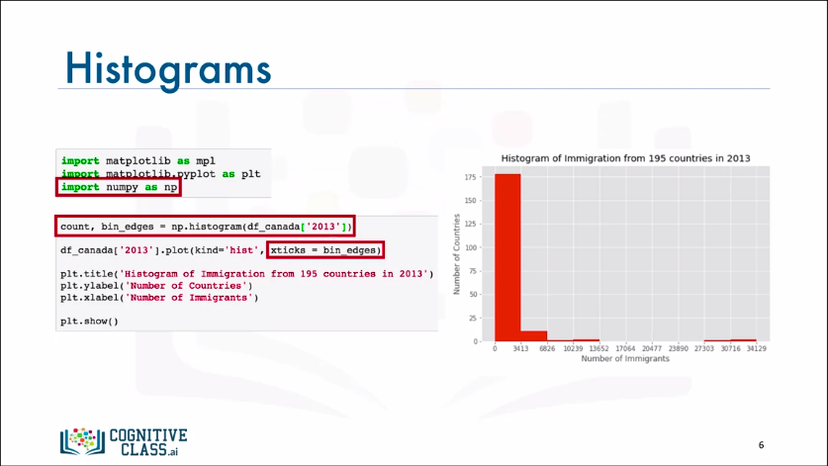

**Bar Charts**

A bar chart is a very popular visualization tool. Unlike a histogram, a bar chart also known as a bar graph is a type of plot where the length of each bar is proportional to the value of the item that it represents. It is commonly used to compare the values of a variable at a given point in time.

